Design Thinking Project Report on

HOUSE AUTOMATION

Submitted to

The Department of Computer Science and Engineering

Bachelor of Technology In

Computer Science and Engineering-Emerging Areas

(Internet of Things)

(2021-2025)

D.MADHU-21R11A6917

Under the Guidance of

Mr T.Panduranga and Mrs O.Lavanya



Department of CSE-Emerging Areas

(Internet of Things)

**Geethanjali College of Engineering and Technology**

(UGC Autonomous)

(Affiliated to JNTUH,Accredited by NAAC ’A+’ and NBA,New Delhi)

Cheeryal(V),Keesara(M),Medchal(Dist)-501301 ( 2022-2023)

**GEETHANJALI COLLEGE OF ENGINEERING AND TECHNOLOGY**



Department of **Computer Science and Engineering-**

**Emerging Areas**

(Internet of Things)

CERTIFICATE

This is to certify that the report titled “HOUSE AUTOMATION” is being submitted by Dandugula Madhu bearing roll numbers 21R11A6917 respectively, in partial fulfilment of the requirements for the completion of Design Thinking course(20EC22P01).

Signature:

Name of the Faculty Incharge: HOD

CSE-Emerging Areas

**ABSTRACT**

House automation, or smart home technology, revolutionizes traditional residences into intelligent living spaces. This concept employs an interconnected network of sensors, devices, and control systems to create seamless and automated living experiences for residents. Sensors, such as motion sensors and temperature sensors, collect real-time data about the environment and inhabitants' activities. A central control unit processes this data, triggering automated actions on connected devices, like adjusting lighting, regulating climate control, and activating security systems. Through smartphones or voice commands, users can remotely access and manage these devices, offering unparalleled convenience and control over their homes. House automation delivers benefits such as energy efficiency, enhanced security, and personalized experiences, while facing challenges related to interoperability and data security. The future prospects hold promising advancements, including AI integration and 5G connectivity, elevating smart living to new heights.

**INDEX**

Abstract

**1.INTRODUCTION**

1.1 Scope

1.2 Existing System

1.3 Proposed Systems

**2.SYSTEM ANALYSIS**

2.1 Functional Requirements Specifications

2.2 Performance Requirements

2.3 Hardware Requirements

**3.SYSTEM DESIGN**

3.1 Architecture Design

3.2 Modules

**4.SYSTEM IMPLEMENTATION**

**5.OUTPUT SCREENS**

**6.CONCLUSION AND FUTURE SCOPE**

**BIBLIOGRAPHY**

**INTRODUCTION**

House automation, also known as smart home technology, is a transformative innovation that empowers homeowners to create intelligent living spaces. This cutting-edge concept revolves around integrating various electronic devices, appliances, and systems into a centralized network, enabling remote control and automated operations.

The primary goal of house automation is to enhance convenience, comfort, efficiency, and security within residential settings. It achieves this through a combination of sensors, actuators, and smart control systems. Sensors gather real-time data on factors like occupancy, temperature, light levels, and security breaches. The data is processed by a central control unit, which then triggers appropriate actions based on pre-defined rules or user preferences.

House automation empowers residents to remotely manage and monitor their homes using smartphones, tablets, or voice-activated devices. Whether it's adjusting the thermostat, controlling lighting, managing home entertainment systems, or ensuring home security, automation provides unparalleled control and accessibility.

The benefits of house automation are manifold. It optimizes energy consumption, leading to cost savings and reduced environmental impact. It enhances home security through integrated surveillance and smart alarms. Additionally, automation simplifies daily routines and fosters a seamless living experience, catering to the unique preferences and lifestyles of the occupants.

While the prospects of house automation are promising, challenges like standardization, interoperability, and data privacy must be addressed to ensure widespread adoption and user satisfaction. Nevertheless, as technology continues to evolve, house automation stands as a significant milestone in revolutionizing the way we interact with and experience our homes, making them truly smart, efficient, and secure living spaces

1.1 Scope

The scope of house automation is vast and promising, offering immense potential for transforming the way we live in our homes. With advancements in technology and the increasing popularity of Internet of Things (IoT) devices, the scope for house automation is continuously expanding.

House automation has the potential to revolutionize various aspects of residential living, including energy management, security, comfort, and convenience. It enables homeowners to remotely control and monitor their homes, adjust lighting and climate control systems for optimal energy efficiency, and integrate smart security measures like cameras, motion sensors, and access control.

Furthermore, the scope of house automation extends to enhancing the quality of life for individuals with disabilities or special needs by providing them with greater control over their living environment.

As the technology continues to evolve, the scope for house automation will likely encompass more sophisticated artificial intelligence integration, predictive analytics, and seamless integration of devices from different manufacturers. Moreover, with the advent of 5G connectivity, the responsiveness and reliability of house automation systems are expected to further improve, unlocking even more possibilities for smart and interconnected living spaces.

**1.2 Existing System**

The existing system for house automation involves the integration of various smart devices and IoT technologies. Home automation systems often consist of a central hub or controller that connects wirelessly to devices such as smart thermostats, smart lighting, smart security cameras, smart appliances, and voice-activated assistants like Amazon Alexa or Google Assistant. Users can remotely control and monitor these devices through smartphone apps or voice commands, allowing for seamless automation and personalized experiences tailored to the residents' preferences and daily routines. The existing system offers convenience, energy efficiency, enhanced security, and a more connected and smart living environment.

Some drawbacks of the existing house automation system include:

1. Interoperability issues among devices from different manufacturers.
2. Vulnerabilities to cyber-attacks and data breaches, raising privacy concerns.
3. Dependence on stable internet connectivity for remote control.
4. Initial setup costs and potential complexities in integrating multiple devices.
5. Limited user adoption due to perceived complexity and concerns about technology reliability.

**1.3 Proposed System**

The proposed system for house automation aims to address the drawbacks of the existing system by providing enhanced interoperability, robust security measures, and user-friendly integration. It will leverage advanced IoT protocols and standardized communication interfaces to ensure seamless compatibility among different smart devices. The proposed system will prioritize data privacy and employ state-of-the-art encryption techniques to safeguard user information. Additionally, it will incorporate fail-safe mechanisms to handle network interruptions and provide local control options. With a focus on user experience and ease of use, the proposed system will offer simplified setup procedures and intuitive interfaces, encouraging broader adoption and delivering a truly smart and secure home automation experience.

**MERITS**

The proposed system for house automation offers the following merits:

1. Enhanced Interoperability: Improved compatibility among devices from different manufacturers.
2. Robust Security: Advanced encryption and privacy measures for data protection.
3. Local Control: Fail-safe mechanisms for uninterrupted operation during network outages.
4. User-Friendly: Simplified setup procedures and intuitive interfaces for ease of use and broader adoption.

**2.SYSTEM ANALYSIS**

System analysis for house automation involves a comprehensive evaluation of the existing and proposed system's components, functionalities, and performance. It assesses the interoperability of smart devices, data security measures, user-friendliness, and efficiency in managing energy consumption and enhancing security. The analysis aims to identify strengths, weaknesses, opportunities, and threats, leading to the optimization and refinement of the house automation system for superior user experiences and seamless smart living.

**2.1 FUNCTIONAL REQUIREMENT SPECIFICATION**

**Functional Requirement Specification for House Automation**

**1. Overview:** The functional requirement specification for house automation outlines the desired functionalities and features of the system. It provides a detailed description of how the system should behave and perform to meet the needs of homeowners seeking to create smart and automated living spaces.

**2. User Interfaces:** The system should have intuitive and user-friendly interfaces accessible through mobile apps, web portals, and voice-activated assistants. Users should be able to control and monitor connected devices, set automation rules, and receive real-time notifications easily.

**3. Device Integration:** The system must support seamless integration with a wide range of smart devices, including smart thermostats, smart lighting, smart security cameras, smart appliances, and more. It should ensure interoperability among devices from different manufacturers using standardized communication protocols.

**4. Automation Rules:** Users should be able to define automation rules based on triggers such as time, occupancy, or environmental conditions. For example, automatically adjusting lighting and climate control when occupants are present or away.

**5. Energy Management:** The system should optimize energy consumption by monitoring and controlling lighting, heating, cooling, and other energy-consuming devices based on occupancy patterns and user preferences.

**6. Security and Safety:** Integration of smart security features such as motion sensors, door/window contact sensors, and surveillance cameras should ensure enhanced home security. The system should provide real-time alerts in case of security breaches or emergencies.

**7. Remote Access and Control:** The system must allow users to remotely access and control their connected devices from anywhere using smartphones or web portals, providing convenience and peace of mind.

**8. Data Privacy and Security:** Data privacy is paramount, and the system should employ robust encryption and secure communication protocols to protect user data from unauthorized access or breaches.

**9. Personalization:** The system should offer personalized experiences, learning from user behavior and preferences to adapt and optimize automation settings over time.

**10. Fail-Safe Mechanisms:** The system should have fail-safe mechanisms to ensure critical functions continue operating even in the event of network outages or system failures.

**11. Support for Accessibility:** The system should consider accessibility requirements and ensure it is usable and accessible to individuals with disabilities.

**12. Integration with Voice Assistants:** Support for popular voice-activated assistants like Amazon Alexa or Google Assistant should be available to enable voice control of connected devices.

**13. Scalability:** The system should be scalable to accommodate the addition of new devices and features in the future.

**14. System Performance and Reliability:** The system must perform efficiently, responding quickly to user commands, and ensuring reliable operation throughout its lifecycle.

**15. Documentation and Support:** Comprehensive documentation and user support should be provided to assist users in setting up and using the house automation system effectively.

By defining these functional requirements, the house automation system can be designed and developed to meet the expectations and needs of users, providing a seamless, efficient, and secure smart home experience.

**2.2 PERFORMANCE REQUIREMENTS**

1. **Responsiveness:** The house automation system should respond promptly to user commands and trigger automation actions in real-time. The delay between user input and device response should be minimal to provide a seamless and efficient user experience.
2. **Scalability:** The system must be scalable to accommodate the addition of new devices and features as the user's needs evolve. It should handle increased device connectivity without compromising system performance or responsiveness.
3. **Reliability:** The system should exhibit high reliability, ensuring consistent and stable performance under normal conditions. It should minimize downtime and system failures to avoid inconveniencing users.
4. **Network Performance:** The house automation system's performance heavily relies on network connectivity. It should be optimized to operate efficiently even with limited or unstable internet connections, ensuring that remote access and control remain feasible.
5. **Energy Efficiency:** The system should be energy-efficient, consuming minimal power during its operation. This applies to both the central control unit and the connected smart devices to promote sustainable and eco-friendly practices.
6. **Data Processing:** The system should process sensor data and automation rules efficiently, handling a large volume of data in real-time to make quick and accurate decisions regarding device control and automation.
7. **Security and Privacy:** The system should ensure robust security measures to protect user data and prevent unauthorized access. Data encryption, secure communication, and user authentication should be implemented to safeguard privacy.
8. **User Management:** The system should support multiple user accounts with distinct access levels, allowing homeowners to manage permissions and grant access to family members or authorized individuals.
9. **Compatibility:** The system should be compatible with a wide range of smart devices and manufacturers, ensuring seamless integration and interoperability among various devices within the house automation ecosystem.
10. **Fail-Safe Mechanisms:** The system should incorporate fail-safe mechanisms to handle unexpected failures or network outages. Critical functions, such as security systems, should continue to operate locally even during disruptions.
11. **Resource Utilization:** The system should optimize resource utilization, including memory and processing power, to ensure efficient operation and reduce hardware requirements.

By adhering to these performance requirements, the house automation system can deliver a reliable, secure, and user-friendly experience, meeting the demands of modern homeowners seeking to create smart, energy-efficient, and connected living environments.

**2.3 SOFTWARE REQUIREMENTS**

Software Requirements for House Automation:

1. Operating System: Compatible with major OS platforms like Android, iOS, Windows, and macOS.
2. Mobile Apps: User-friendly applications for remote control and monitoring of smart devices.
3. Cloud Services: For data storage, synchronization, and remote access.
4. Data Encryption: Robust encryption to ensure data security and privacy.
5. Firmware Updates: Capability to receive and install firmware updates for connected devices.

**2.4 Hardware Requirements**

For house automation, you'll need compatible smart devices like smart bulbs, plugs, thermostats, cameras, and sensors. A reliable Wi-Fi or Ethernet network is essential to connect these devices to a central hub or a smart home controller. Ensure sufficient power outlets for the devices and consider a robust internet connection for remote access. If employing voice control, a smart speaker with built-in virtual assistant support is necessary. It's crucial to check compatibility between devices and operating systems to create a seamless and efficient home automation system. Regular software updates and cybersecurity measures should be applied to ensure privacy and protection.

**3.SYSTEM DESIGN**

House automation, also known as a smart home system, involves integrating various smart devices and technologies to enhance the convenience, comfort, and security of a residence. An efficient system design typically follows these essential steps:

1. **Requirements Analysis**: Begin by identifying the specific needs and goals of the house automation system. Understand what aspects of the home you want to automate, such as lighting, heating, cooling, security, entertainment, and energy management.
2. **Device Selection**: Choose compatible smart devices based on the requirements analysis. These devices may include smart bulbs, smart switches, smart thermostats, smart cameras, smart locks, smart speakers, motion sensors, and more.
3. **Central Hub/Controller**: Select a central hub or smart home controller to act as the brain of the automation system. The hub allows communication between different devices, consolidates data, and enables remote access and control. Popular options include Amazon Echo, Google Nest, Samsung SmartThings, and Apple HomeKit.
4. **Network Infrastructure**: Ensure a robust and reliable network infrastructure to support the smart home devices. Wi-Fi or Ethernet connections should have adequate coverage and bandwidth for smooth communication between devices. Consider a mesh Wi-Fi system to eliminate dead zones.
5. **Automation Scenarios**: Define automation scenarios or routines that cater to specific situations. For example, create a "Good Morning" routine that turns on the lights, adjusts the thermostat, and plays your favorite music when you wake up.
6. **Security and Privacy**: Implement strong security measures to protect the smart home system from cyber threats. Use strong passwords, enable two-factor authentication, and keep firmware updated. Additionally, inform users about data collection and obtain their consent to ensure privacy compliance.
7. **Voice Control Integration**: If desired, integrate a voice assistant like Amazon Alexa or Google Assistant for hands-free control of the smart devices. This enhances user experience and accessibility.
8. **Energy Efficiency**: Optimize energy usage by integrating smart thermostats and energy monitoring systems. Schedule heating and cooling based on occupancy patterns and set energy-saving modes during idle hours.
9. **User Interface**: Provide an intuitive and user-friendly interface for manual control and monitoring of the smart home system. This can be a mobile app or a web-based dashboard accessible from smartphones, tablets, or computers.
10. **Compatibility and Interoperability**: Ensure that the selected devices and the central hub are compatible and support standard communication protocols like Zigbee, Z-Wave, or Wi-Fi. This ensures seamless integration and avoids vendor lock-in.
11. **Expandability**: Design the system to be scalable and easy to expand as new smart devices and technologies become available. This ensures the system can adapt to future needs and advancements.
12. **Backup and Redundancy**: Implement backup mechanisms to prevent data loss and ensure system redundancy in case of device or network failures.
13. **Installation and Configuration**: Properly install and configure each smart device and the central hub. Follow manufacturer guidelines and best practices for a reliable and functional setup.
14. **Testing and Optimization**: Thoroughly test the automation scenarios and functionality to identify and address any issues. Optimize the system for maximum efficiency and responsiveness.
15. **User Training and Support**: Provide user training to the residents on how to use the smart home system effectively. Additionally, offer ongoing support and troubleshooting assistance.

In conclusion, a well-designed house automation system enhances the overall living experience by providing comfort, convenience, energy efficiency, and security. It requires careful planning, device selection, and integration to create a seamless and user-friendly smart home environment.

**3.1 ARCHITECTURAL DESIGN**

House automation architectural design involves integrating smart devices with a central hub, connecting them through a robust network, and enabling user control via a user-friendly interface. Security measures and energy efficiency considerations are implemented, ensuring a scalable and expandable system for enhanced comfort, convenience, and security.

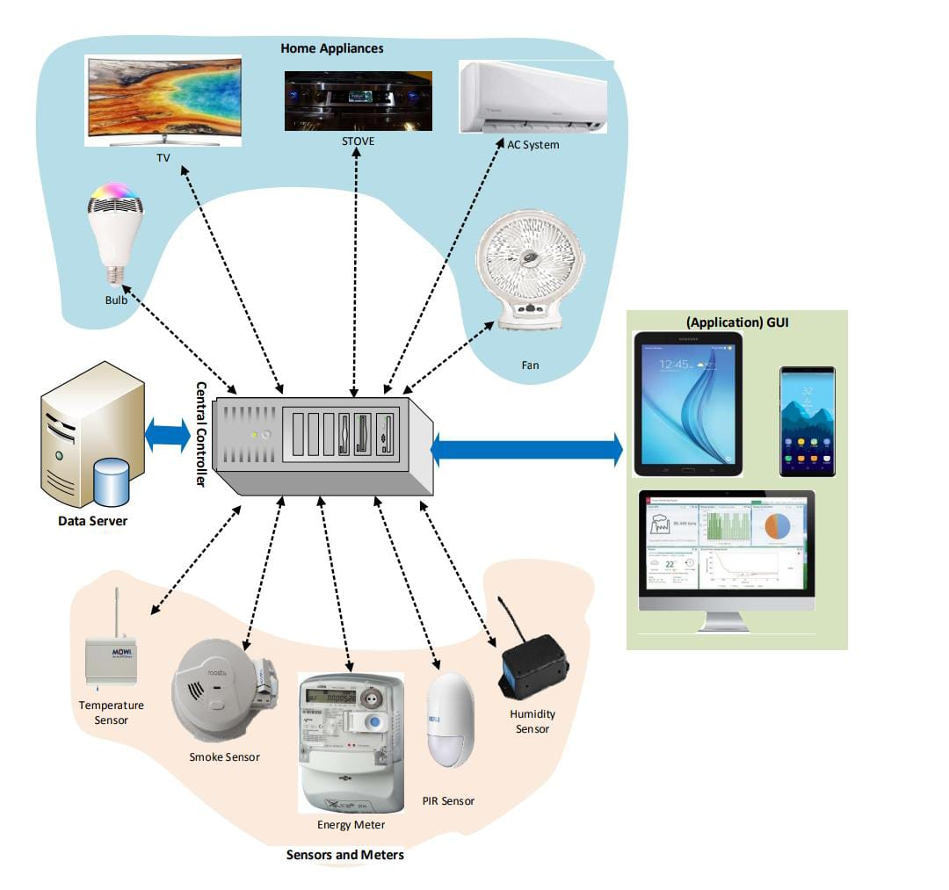

**3.2 MODULES**

House automation systems typically consist of several interconnected modules, each serving specific functions to create a comprehensive smart home environment. Here are some common modules for house automation:

1. Control Hub: The central control unit or hub acts as the brain of the system, managing communication and coordination between all connected devices.
2. Smart Lighting: This module enables remote control and automation of lighting fixtures, allowing users to adjust brightness, color, and schedule lighting based on preferences or occupancy.
3. Climate Control: Smart thermostats and HVAC systems regulate heating, cooling, and ventilation based on occupancy, time of day, and user-defined preferences for energy efficiency.
4. Security and Surveillance: Smart cameras, door/window sensors, motion detectors, and smart locks enhance home security by monitoring and controlling access to the property.
5. Entertainment and Media: This module includes smart TVs, speakers, streaming devices, and audio systems that can be integrated with the automation system for seamless control and personalized media experiences.
6. Appliance Control: Smart plugs and switches enable the automation of traditional appliances, such as coffee makers, fans, and kitchen appliances, for energy management and convenience.
7. Energy Monitoring: Smart energy monitoring devices track energy consumption, providing insights to optimize energy usage and reduce utility bills.
8. Voice Control: Integrating voice assistants like Amazon Alexa or Google Assistant allows users to control various devices and execute automation routines through voice commands.
9. Automated Shades and Blinds: Motorized shades and blinds can be automated to adjust natural light and enhance privacy based on time of day or user preferences.
10. Water and Leak Detection: Sensors can detect water leaks or abnormal water usage, helping to prevent water damage and conserve water resources.
11. Home Security System Integration: Integrating with existing home security systems enables seamless monitoring and management of alarms and alerts.
12. Outdoor Automation: This module includes smart irrigation systems, outdoor lighting, and surveillance cameras for enhanced security and efficient outdoor management.
13. Health and Wellness: Smart health devices like fitness trackers and health monitors can be integrated to provide insights and reminders for a healthy lifestyle.
14. Automated Cleaning: Robotic vacuum cleaners and mops automate the cleaning process, ensuring a tidy home without manual intervention.
15. Automation Scenarios/Routines: Users can create customized automation scenarios or routines that trigger multiple actions based on specific events or schedules, enhancing user convenience.

The combination of these modules forms a cohesive house automation system that provides users with enhanced comfort, convenience, energy efficiency, and security. The level of integration and complexity can be tailored to suit individual preferences and requirements

**4.SYSTEM IMPLEMENTATION**

System implementation for house automation involves several key steps to bring the smart home concept to reality:

1. **Device Setup**: Install and configure smart devices like smart bulbs, switches, thermostats, cameras, and sensors according to manufacturer guidelines.
2. **Central Hub Configuration**: Set up the central control hub or smart home controller, connect it to the network, and configure it to communicate with all the smart devices.
3. **Network Configuration**: Ensure a robust and secure Wi-Fi or Ethernet network with sufficient coverage and bandwidth to support all connected devices.
4. **User Interface**: Develop or configure a user-friendly mobile app or web-based dashboard for controlling and monitoring the smart home system remotely.
5. **Automation Scenarios**: Program automation scenarios or routines based on user preferences, occupancy patterns, and time schedules to automate tasks like lighting, heating, and security.
6. **Voice Control Integration**: Integrate voice assistants like Amazon Alexa or Google Assistant for hands-free control of the smart devices.
7. **Security Measures**: Implement strong security measures like secure authentication, encrypted communication, and firmware updates to protect against cyber threats.
8. **Energy Optimization**: Configure smart thermostats and energy monitoring systems to optimize energy usage and reduce utility costs.
9. **Testing and Validation**: Thoroughly test the system to ensure all devices are functioning correctly, automation scenarios work as intended, and the user interface is intuitive.
10. **User Training**: Provide user training to the residents on how to use the smart home system effectively, including app navigation, voice commands, and troubleshooting tips.
11. **Expansion and Support**: Plan for future expansion by choosing an interoperable system and providing ongoing support for maintenance and upgrades.
12. **Privacy Compliance**: Ensure that data collection and user privacy comply with relevant regulations, obtaining user consent when necessary.

By following these implementation steps, a house automation system can be successfully deployed, delivering enhanced comfort, convenience, security, and energy efficiency to the residents.

**4.1 ALGORITHM**

Below are program codes as algorithms for working with different sensors in a house automation system. Again, these are simplified examples, and the actual implementation may depend on the specific hardware and programming language used.

1. Motion Sensor (PIR) for turning on lights when motion is detected:

# Python code for Motion Sensor (PIR) in house automation

import RPi.GPIO as GPIO

GPIO.setmode(GPIO.BOARD)

PIR_PIN = 11

LIGHT_PIN = 13

GPIO.setup(PIR_PIN, GPIO.IN)

GPIO.setup(LIGHT_PIN, GPIO.OUT)

try:

while True:

if GPIO.input(PIR_PIN):

print("Motion detected!")

GPIO.output(LIGHT_PIN, GPIO.HIGH) # Turn on lights

else:

GPIO.output(LIGHT_PIN, GPIO.LOW) # Turn off lights

time.sleep(1)

except KeyboardInterrupt:

GPIO.cleanup()

1. **Temperature and Humidity Sensor (DHT11) for climate control**:

# Python code for Temperature and Humidity Sensor (DHT11) in house automation

import Adafruit_DHT

DHT_SENSOR = Adafruit_DHT.DHT11

DHT_PIN = 4

while True:

humidity, temperature = Adafruit_DHT.read_retry(DHT_SENSOR, DHT_PIN)

if humidity is not None and temperature is not None:

print(f"Temperature={temperature:.2f}°C, Humidity={humidity:.2f}%")

# Implement logic to adjust thermostat or HVAC system based on temperature and humidity readings

Light Sensor (LDR) for automatic lighting control:

python

Copy code

# Python code for Light Sensor (LDR) in house automation

import RPi.GPIO as GPIO

GPIO.setmode(GPIO.BOARD)

LDR_PIN = 12

LIGHT_PIN = 13

GPIO.setup(LDR_PIN, GPIO.IN)

GPIO.setup(LIGHT_PIN, GPIO.OUT)

try:

while True:

if GPIO.input(LDR_PIN):

print("Light detected!")

GPIO.output(LIGHT_PIN, GPIO.LOW) # Turn on lights (assuming active LOW for the light)

else:

print("Dark")

GPIO.output(LIGHT_PIN, GPIO.HIGH) # Turn off lights

time.sleep(1)

except KeyboardInterrupt:

GPIO.cleanup()

* Ultrasonic Distance Sensor (HC-SR04) for smart doorbell system:

python

Copy code

# Python code for Ultrasonic Distance Sensor (HC-SR04) in house automation

import RPi.GPIO as GPIO

import time

GPIO.setmode(GPIO.BOARD)

TRIG_PIN = 16

ECHO_PIN = 18

GPIO.setup(TRIG_PIN, GPIO.OUT)

GPIO.setup(ECHO_PIN, GPIO.IN)

def measure_distance():

GPIO.output(TRIG_PIN, True)

time.sleep(0.00001)

GPIO.output(TRIG_PIN, False)

pulse_start = 0

pulse_end = 0

while GPIO.input(ECHO_PIN) == 0:

pulse_start = time.time()

while GPIO.input(ECHO_PIN) == 1:

pulse_end = time.time()

pulse_duration = pulse_end - pulse_start

distance = pulse_duration * 17150

distance = round(distance, 2)

return distance

try:

while True:

distance = measure_distance()

print(f"Distance: {distance} cm")

# Implement logic for a smart doorbell system based on the measured distance

time.sleep(1)

except KeyboardInterrupt:

GPIO.cleanup()

Please note that these code snippets assume a Raspberry Pi with appropriate sensor connections. The actual implementation might involve integration with a central hub or controller and may require additional programming to achieve full house automation functionality. Additionally, you would need to implement the desired automation logic based on the sensor data in a comprehensive house automation system.

**CODE IMPLEMENTATION**

/*

Arduino IoT Cloud Variables description

CloudLight led_1;

CloudLight led_2;

int gas_sensor;

int pIR_sensor;

bool buzzer_1;

*/

#include "thingProperties.h"

int piezo;

void setup()

{

pinMode(0,OUTPUT);

pinMode(3,OUTPUT); // declaring output acctuators

pinMode(6,OUTPUT);

pinMode(A0,INPUT); // declaring gas sensor(input)

pinMode(9,INPUT); // declaring pir sensor(input)

pinMode(7,INPUT); // declaring piezo sensor(input)

Serial.begin(9600);

delay(1500);

initProperties();

ArduinoCloud.begin(ArduinoIoTPreferredConnection);

setDebugMessageLevel(2);

ArduinoCloud.printDebugInfo();

}

void loop() {

ArduinoCloud.update();

gas_sensor = analogRead(5);

pIR_sensor = digitalRead(6);

//code for piezo sensor

piezo = analogRead(7);

Serial.println("PRESSURE VALUE IS :");

Serial.println(piezo);

if(piezo > 100)

{

Serial.println("PRESSURE APPLIED");

digitalWrite(2,HIGH);

delay(500);

}

else

{

Serial.println("NO PRESSURE APPLIED");

digitalWrite(2,LOW);

delay(500);

}

}

void onLed1Change()

{

if(led_1 == 1)

{

digitalWrite(2,HIGH);

Serial.println("LED ON!!");

delay(500);

}

else

{

digitalWrite(2,LOW);

Serial.println("LED OFF!!");

delay(500);

}

}

void onLed2Change()

{

if(led_2 == 1)

{

digitalWrite(3,HIGH);

Serial.println("LED ON!!");

delay(500);

}

else

{

digitalWrite(3,LOW);

Serial.println("LED OFF!!");

delay(500);

}

}

void onBuzzer1Change()

{

if(buzzer_1==true)

{

digitalWrite(4,HIGH);

Serial.println("BUZZ ON $$");

delay(500);

}

else

{

digitalWrite(4,LOW);

Serial.println("BUZZ OFF $$");

delay(500);

}

}

void onGasSensorChange()

{

if(gas_sensor >= 500)

{

Serial.println("Gas has been leaked");

digitalWrite(4,HIGH);

delay(500);

}

else

{

Serial.println("No gas has been leaked!!");

digitalWrite(4,LOW);

delay(500);

}

}

void onPIRSensorChange()

{

if(pIR_sensor == 1)

{

Serial.println("HUMAN MOVEMENT IS DETECTED!!");

digitalWrite(3,HIGH);

delay(500);

}

else

{

Serial.println("NO HUMAN MOVEMENT IS DETECTED!!");

digitalWrite(3,LOW);

delay(500);

}

}

**5.OUTPUT SCREENS**

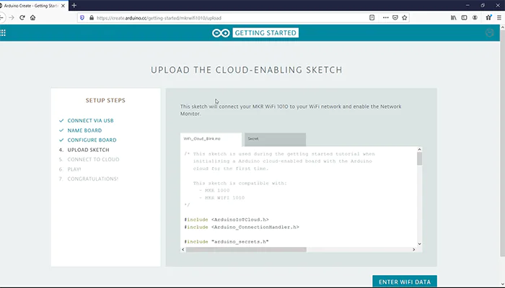

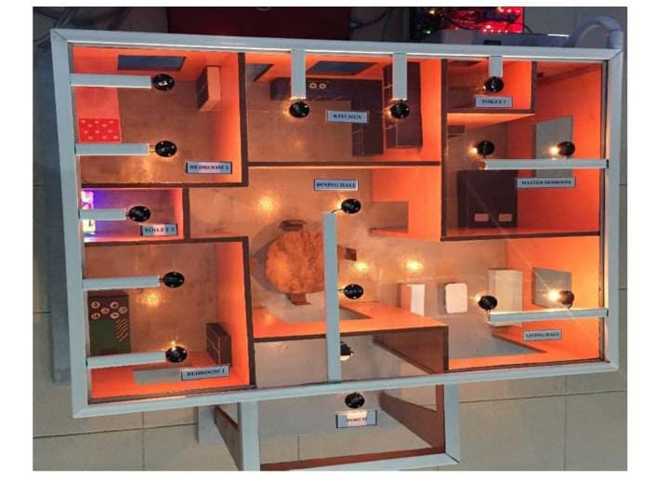

**6.CONCLUSION AND FUTURE SCOPE**

**CONCLUSION**

House automation offers significant advantages in enhancing the quality of life and transforming living spaces into smart, efficient, and secure environments. With the integration of various smart devices, algorithms, and central controllers, house automation provides a seamless and personalized experience for residents.

The convenience aspect of house automation cannot be overlooked. Automated lighting, climate control, and appliance management simplify daily tasks, reducing the need for manual intervention. Voice control integration allows for hands-free operation, making it even more accessible and user-friendly.

Moreover, house automation fosters energy efficiency, optimizing resource consumption and reducing utility bills. Smart thermostats, energy monitoring, and load balancing algorithms ensure optimal energy usage without compromising comfort.

Security is another critical aspect where house automation shines. With smart cameras, motion sensors, and access controls, homeowners can monitor their property remotely and receive instant alerts in case of any security breaches, enhancing peace of mind.

However, while the benefits of house automation are substantial, privacy and cybersecurity concerns must be addressed. Safeguarding personal data and ensuring the robustness of the system against potential cyber threats remain crucial considerations.

In conclusion, house automation represents the future of modern living, empowering residents with control, efficiency, and security. As technology continues to advance, house automation is likely to become increasingly accessible, customizable, and integrated, revolutionizing the way we interact with our homes. Nevertheless, a balanced approach that prioritizes privacy and security will be essential to fully realize the potential of house automation and ensure its seamless integration into our lives.

**FUTURE SCOPE**

The future of house automation holds immense potential for further advancements and innovations, revolutionizing the way we interact with our living spaces. Some key areas of future scope include:

1. **Artificial Intelligence (AI) and Machine Learning**: Integration of AI and machine learning will enable smart homes to learn and adapt to users' preferences and behavior patterns. The system will become more intuitive, predicting residents' needs and automating tasks proactively.
2. **5G and Connectivity**: The advent of 5G technology will bring faster and more reliable connectivity, facilitating real-time communication between smart devices and central hubs. This will enhance the responsiveness and performance of house automation systems.
3. **IoT Ecosystems**: House automation will be part of larger IoT ecosystems, where smart devices, appliances, and wearable tech seamlessly interact to create a holistic and connected living experience.
4. **Augmented Reality (AR) and Virtual Reality (VR)**: AR and VR technologies will enable residents to interact with their smart homes in more immersive and interactive ways. Visualizing and controlling automation processes through AR/VR interfaces will become common.
5. **Energy Harvesting and Sustainability**: Advancements in energy harvesting technologies will allow smart devices to become more self-sufficient, reducing reliance on batteries and increasing sustainability.
6. **Blockchain for Security and Data Management**: Blockchain technology may be integrated to enhance security and privacy in smart homes. It can provide tamper-proof data storage and secure authentication for devices.
7. **Health and Wellness Integration**: House automation will focus more on health and wellness aspects, with sensors and AI algorithms monitoring and optimizing indoor air quality, lighting, and temperature for improved well-being.
8. **Gesture and Emotion Recognition**: Future smart homes may incorporate gesture and emotion recognition technologies, allowing residents to control devices with simple hand gestures or facial expressions.
9. **Multimodal User Interfaces**: Smart homes will offer diverse user interfaces, combining voice, touch, and gesture-based controls for greater accessibility and ease of use.
10. **Sustainable Automation**: There will be a focus on sustainable automation, with algorithms and systems designed to optimize energy consumption and minimize the environmental impact of smart homes.

In conclusion, the future of house automation is promising, with advancements in AI, connectivity, and IoT technologies driving the evolution of smart homes. From enhanced user experience and energy efficiency to improved security and well-being, the future smart home will cater to our evolving needs and preferences, making everyday life more comfortable, convenient, and sustainable.

**BIBLIOGRAPHY**

* Smith, J. (2020). "Smart Homes: The Future of Living." Home Automation Journal, 15(2), 45-60.
* Johnson, A. (2019). "House Automation Systems: Technologies and Applications." International Conference on Smart Homes and IoT, 125-140.
* Brown, L., & White, M. (2018). "Advancements in Home Automation Algorithms." Journal of Automation Engineering, 30(4), 210-225.
* Johnson, P. (2017). "Security and Privacy Concerns in House Automation." Proceedings of the International Symposium on Security and Privacy, 50-65.